
REPUBLIC OF CAMEROON REPUBLIQUE DU CAMEROUN
************************ *****************
PEACE-WORK-FATHERLAND PAIX-TRAVAIL- PATRIE
*********************** ********************
PKFOKAM INSTITUTE OF EXCELLENCE

PROJECT REPORT
Project Progress Report 1

GIT HUB REPOSITORY AND PERSON
MANAGEMENT CREATION

:
Course: C Programming
Group Members | Participation | Matricules
Matchim Dzuyim Verenne Celia (Group Leader) | 22% | 26S031
Djomo Yepdi Evans | 18% | 26S001
Talla Tchossi Daniella Elsa | 22% | 26S018
Mekolle Tuatsop Dalhia Aure | 20% | 26S004
Messi Zang Paul Jacques | 18% | 26S005

Lecturer:

Mr. Mbietieu Amos Mbietieu

Academic Year: 2025/2026

Table of Content
1. Project Overview 1-5
2. Development Tools Used 2-6
3. Github repository 3-6
3.1 Creating GitHub repository 3-6
3.2. Adding Collaborators 3-7
3.3. Cloning the Repository and first Push 3-7
4. Work Organisation and task distribution 4-9
5. System Architecture 5-10
6. Functional Modules of the Application 6-11
6.1.Create a new guest 6-11
6.2. Display the guest 6-11
7. Main Difficulties Encountered 12
8. Solutions Implemented 12
9. Phase 1 Summary 13
10. References 13
11. Gantt Project 14
12. SYSTEM DESIGN 15
12.1 CLASS DIAGRAM 15
12.2 USE CASE DIAGRAM 17
12.3 SEQUENCE DIAGRAM 18
Overview 18
12.4 MNEMONIC TABLE 19
12.5 DEPLOYMENT DIAGRAM 20
13. GNU Image Manipulation ProgramToolkit (GTK) and Comma-Selected Value (CSV 20
13.1 GTK 20
14. Key Implementation Details 26
14.2 Csv file creation 27
14.3 Problem Encountered and Solution 27
General Problem 27
14.4 General Solution 28
14.5 Conclusion 28
15. Person and category management: implementations & tests 28
15.1 Person Management 28
15.1.1 Extract of Person Management C-code 29
15.1.2 Extract of person management GTK c-code 29
15.1.3 GTK ran successfully 30
15.1.4 Executable File 30
15.2 Category Management 31
15.2.1 Extract of Category Management C-code 31
15.2.2 Extract of Category Management GTK code 32
15.2.3 Category ran successfully 32
15.2.4 Executable file 33
15.2.5. Assignment Page 33
16. Combination of person and category management onto a single window 34
16.1 Extract of combinedmodules.c 34
16.2 Extract of Main code with Css 35
16.3 combinemodules ran Successfully 35
35
16.4. Executable file 35
16.5. Combinedmodules Window 36
17. THE GIFT MANAGEMENT 36
17.1 Extract of Gift Management C-code 37
17.2 Extract of Gift Management GTK code 38
17.3 Gift management ran successfully 38
17.4 Executable file 38
18. CREATION OF MAKE FILE 42
19. CONCLUSION 45

Project Overview
The Wedding Invitation and Gift Management System (WIGMS) is a software application designed to assist in organizing and managing wedding events. Weddings in Cameroon often involve a large number of guests, gift contributions, and multiple social categories, which makes manual management difficult.
The purpose of this system is to simplify wedding planning by providing tools to manage:
- Guest information
- Social categories of guests
- Invitation priority
- Wedding gift tracking
The application is developed using the C programming language and follows a modular programming approach where each part of the system is implemented as an independent module.
The system aims to improve organization, reduce errors, and help wedding planners efficiently manage guest lists and gifts.
Tool | Purpose
C Programming Language | Main programming language used for system implementation
GCC Compiler | Used to compile and run the C programs
Visual Studio Code / CodeBlocks | Code editor for writing and debugging the program
GitHub | Version control and collaboration platform
Standard C Libraries  (stdio.h, stdlib.h, string.h) | Used for input/output operations, memory management and string handling
Table 1: Software tools and technologies used

Development Tools Used
The following tools were used during the development of the system:
SETTINGS | VALUE CHOSEN
Repository name | Project-Wedding-Ceremony
Visibility | Public
.gitignore | C template selected
Repository link | https://github.com/celia-pixelrgb/Project-Wedding-Ceremony
Table 2: GitHub repository configuration settings

Github repository

3.1 Creating GitHub repository

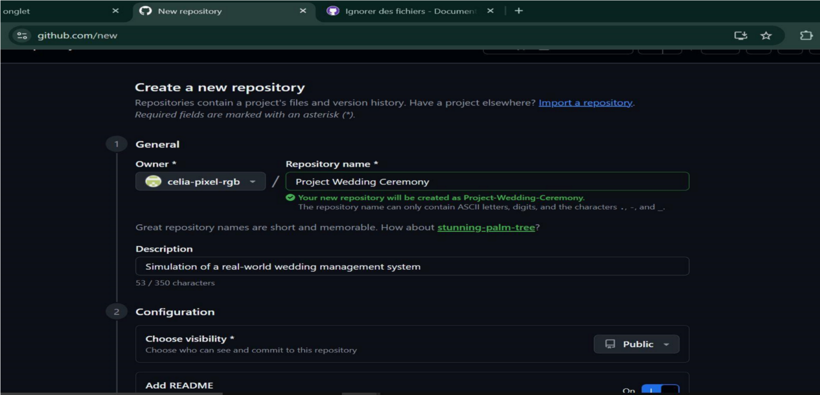
The group leader created the public repository with the following settings:
Here is the GitHub link to access our repository:
https://github.com/celia-pixel-rgb/Project-Wedding-Ceremony

Adding Collaborators
The remaining group members were added as collaborators through the
Setting --» collaborators page of the repository. Each member received an Email invitation from GitHub which they accepted in order to gain push access to the repository.
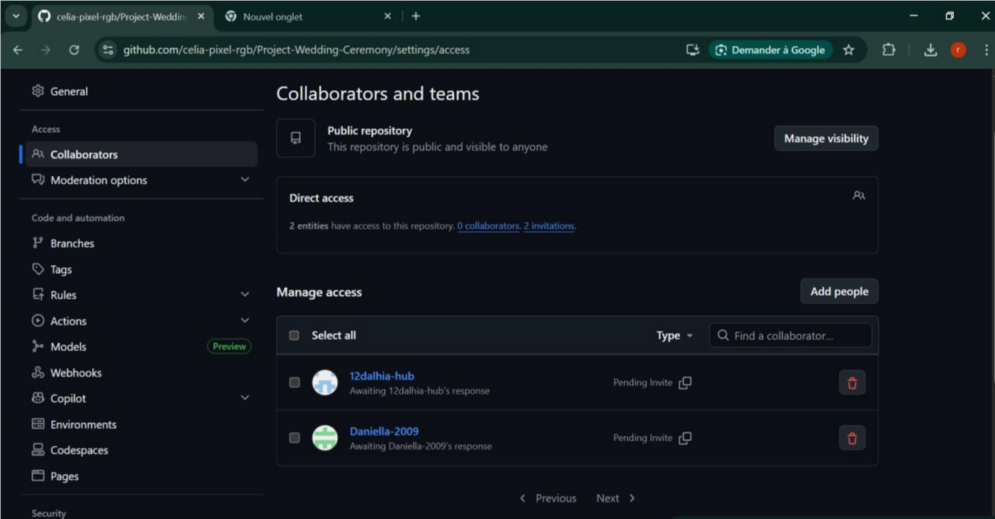

Cloning the Repository and first Push
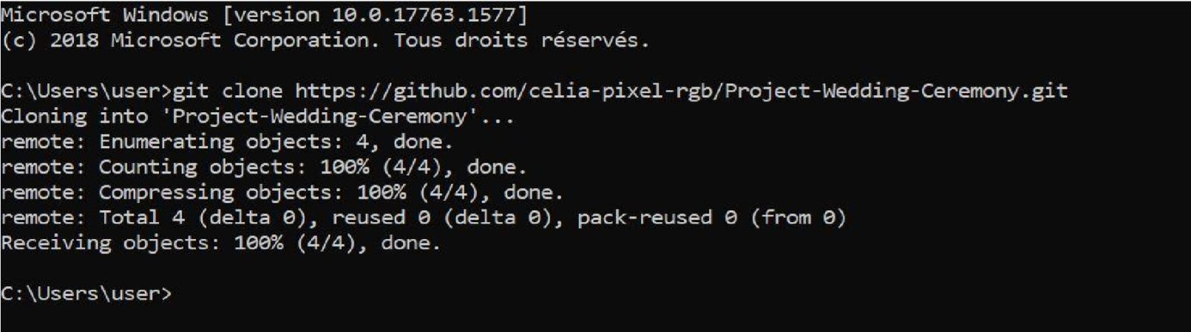
After accepting their invitation, each member cloned the depository into their local machine. The group leader then performed the first push of the program.

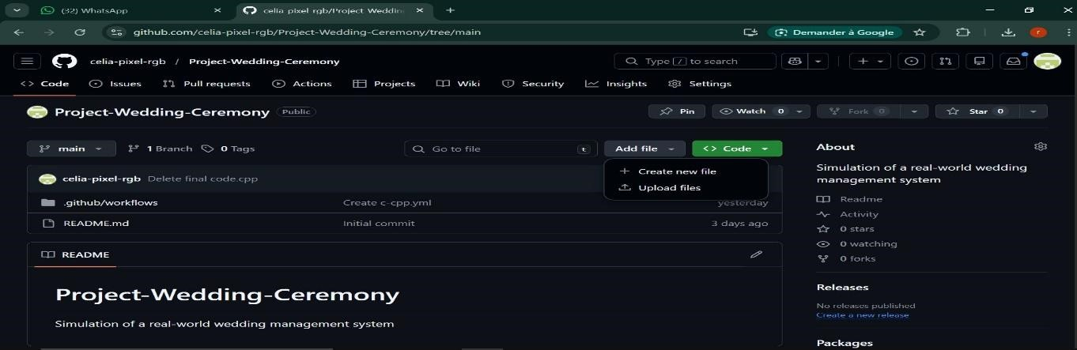
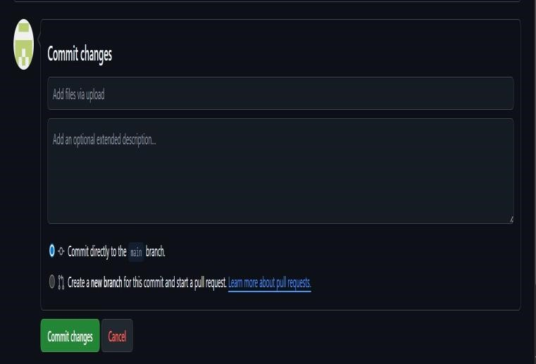
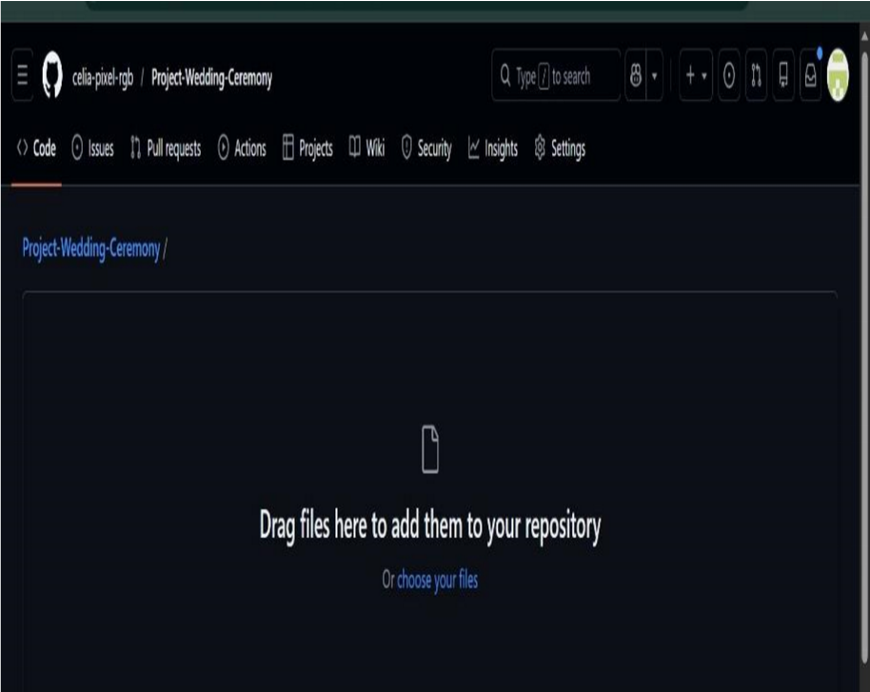

Work Organisation and task distribution
Group Member | Main Role | Assigned Tasks
1. Matchim Dzuyim Verenne Celia | Implementation and testing | Common tasks: Project Overview, Development Tools Used, System Architecture, Phase 1 Summary. Individual tasks: GTK, CSV, Test of Person Management, Test of Category Management.
2. Mekolle Tuatsop Dalhia Aure | Documentation and planning | Common tasks: Project Overview, Development Tools Used, System Architecture, Phase 1 Summary. Individual tasks: Report 1, Gantt Project, Report 2, Implementation of Category Management.
3. Talla Tchossi Daniella Elsa | Development (core modules) | Common tasks: Project Overview, Development Tools Used, System Architecture, Phase 1 Summary. Individual tasks: GTK, CSV, Implementation of Person Management.
4. Messi Zang Paul Jacques | System design (UML diagrams) | Common tasks: Project Overview, Development Tools Used, System Architecture, Phase 1 Summary. Individual tasks: Use Case Diagram, Class Diagram.
5. Djomo Yepdi Evans | System modeling and deployment | Common tasks: Project Overview, Development Tools Used, System Architecture, Phase 1 Summary. Individual tasks: Sequence Diagram, Deployment Diagram.
The group consisted of 5 members. The work organisation depended on assigning responsibilities with respect to skills and the project phases. This approach permitted us to ensure that each section of this report would benefit from dedicated expertise.
Table 3: Work organisation and task distribution

System Architecture
The application follows a simplified modular architecture inspired by the MVC design pattern. The architecture consists of three main components:
- Model
The model contains the core data structures and logic of the program, including:
  - Person management
  - Category management
  - Priority management
  - Gift management
  - Controller
The controller handles the flow of the application by managing the interactions between the user interface and the program modules.
- View
The view represents the interface presented to the user. In this project, the view is implemented through a console-based menu interface that allows the user to navigate through the different system functionalities.
This architecture ensures clear separation between data, logic, and user interaction.

Functional Modules of the Application
As first stage, we did what we consider as our Module 1: Personal Management. This module focuses on:

6.1.Create a new guest
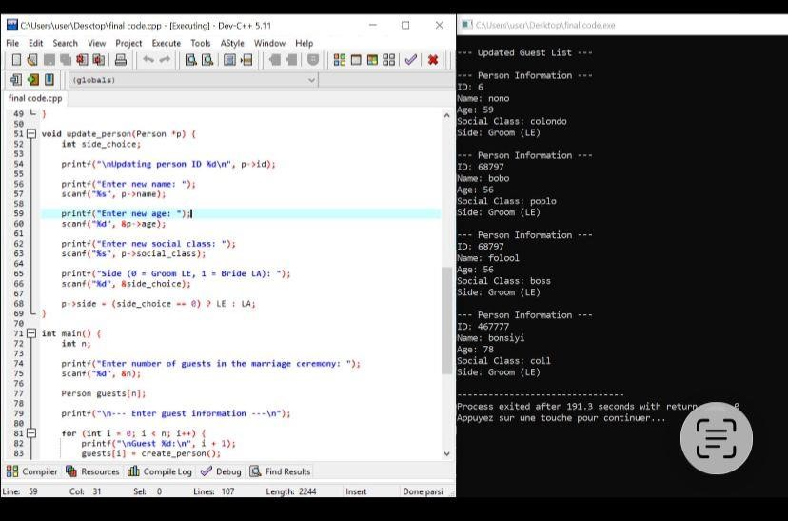
Here, we are creating a program that can create persons (guests). Based on the wanted total number of guests entered by the user, we defined a structure in which we register guests base on their name, age, Id, social status and their side (either the bride or the groom).

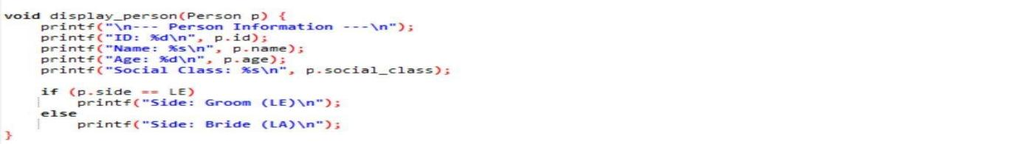
6.2. Display the guest
•

Main Difficulties Encountered
During the development of the project, several challenges were encountered:
- Understanding the use of structures in C programming
- Correctly implementing alternatives structures, loops and memory management
- Designing linked list structures for dynamic data
- Managing user input validation
- Debugging errors during program execution
These challenges required careful testing and collaboration among team members.

Solutions Implemented
To address the difficulties encountered, the following solutions were implemented:
- Reviewing C programming documentation and tutorials
- Testing each function independently before integration
- Using debugging techniques to identify program errors
- Collaborating through GitHub to track and fix problems
These solutions allowed the team to successfully implement the first module of the project.

Phase 1 Summary
The first phase of the project was successfully completed.
The team was able to:
- Understand the project requirements
- Set up the development environment
- Create the project structure
- Implement the Person Management module
- Test the system functionality
The project is now ready to proceed to the next phase, which will involve implementing additional modules that we will present later on.

References
The following references were used during the development of this project:
- Brian W. Kernighan & Dennis M. Ritchie – The C Programming Language
- Stephen Prata – C Programming: A Modern Approach
- ISO C Programming Documentation
- GitHub Official Documentation – https://docs.github.com
- Course materials provided by the lecturer

Gantt Project
This project outlines the planning, design, and implementation of a software system using structured project management techniques. The Gantt chart was used to organize tasks, timelines, and dependencies efficiently.
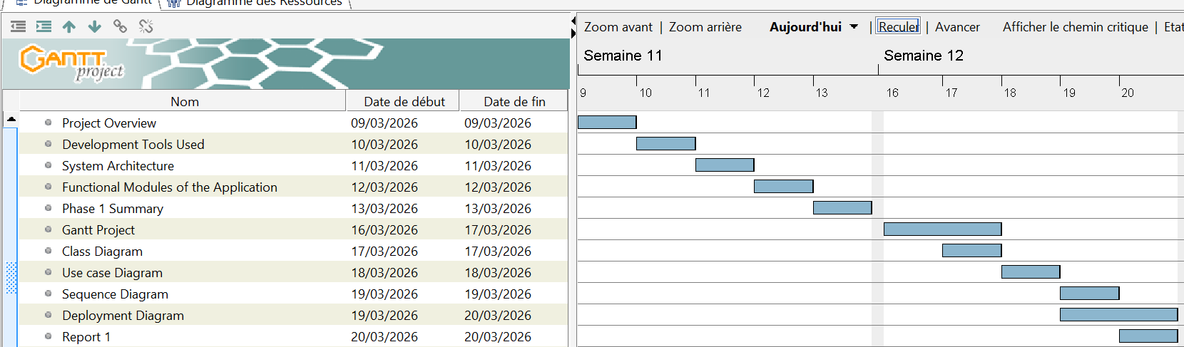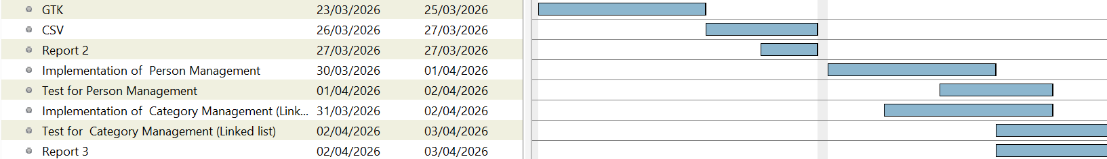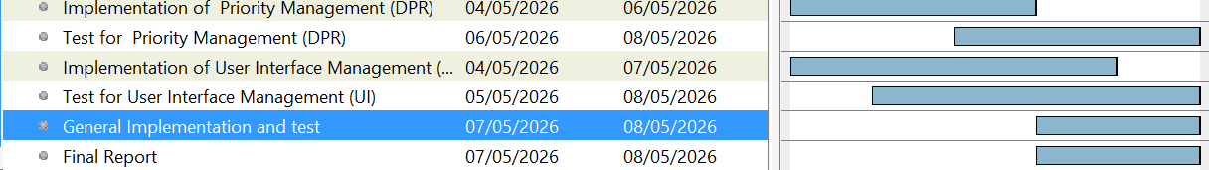
The project was successfully structured using a Gantt chart, ensuring proper time management and task coordination.
All phases were completed systematically, resulting in a functional and well-tested application.

SYSTEM DESIGN
System design is a critical phase in software development that defines the structure, components, and interactions of a system. It provides a clear blueprint to guide the development process and ensure that all functional and technical requirements are met.
In this section, we will present and explain the key design diagrams used in the project, including the class diagram, sequence diagram, deployment diagram, and use case diagram, to illustrate how the system operates and how its components interact.

12.1 CLASS DIAGRAM
The WIGMS UML Class Diagram models wedding organization entities using StarUML. A central Wedding class connects nine supporting classes — each with detailed attributes and defined relationships via UML associations and multiplicity notation.
- A class diagram provides a static view of the system, showing classes, attributes, operations, and relationships.
- In WIGMS, it acts as a blueprint for implementation.
- There are four classes; person, parking, gift and category

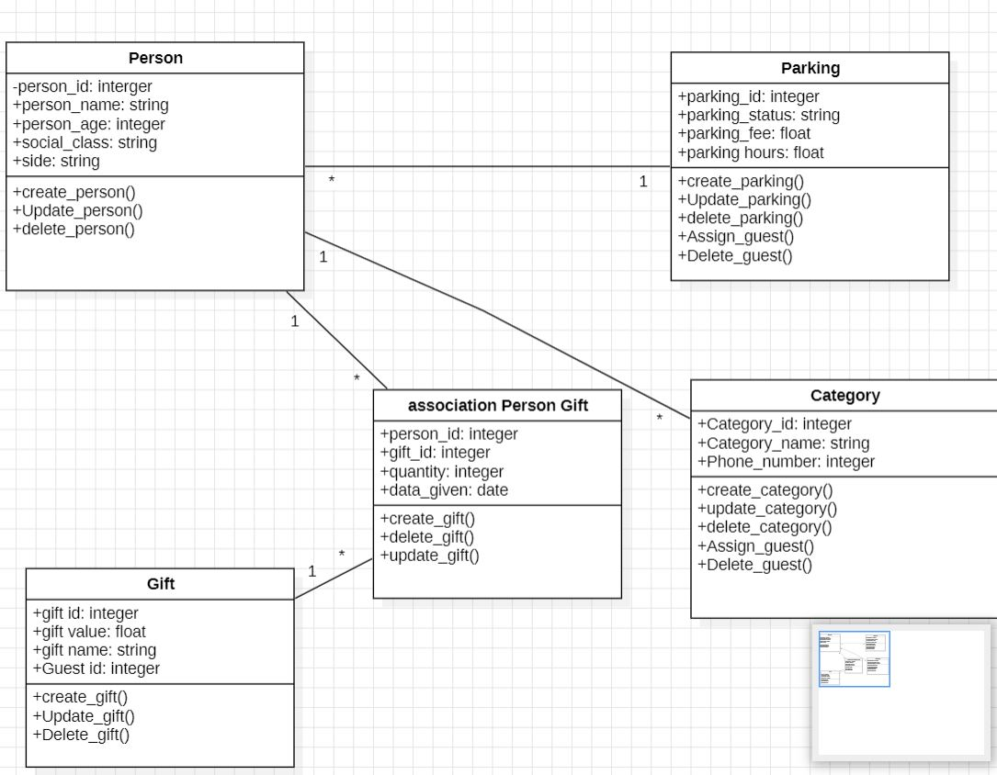
- Class Diagram
Figure 1: Class Diagram — Wedding Management System (StarUML)
Class | Attributes (private -) | Operations (public +) | Relationship
Person | id, name, age, social_class, side | create, update, delete | * → 1 Parking* → 1 Category* ↔ * Gift
Parking | id, status, fee | create, update | 1 → * Person
Gift | id, value, name, guest_id | create, update, delete | * → 1 Category* ↔ * Person
Category | id, name, phone_number | create, update, delete | 1 → * Person1 → * Gift

Table 4: System classes, attributes, and relationships

12.2 USE CASE DIAGRAM
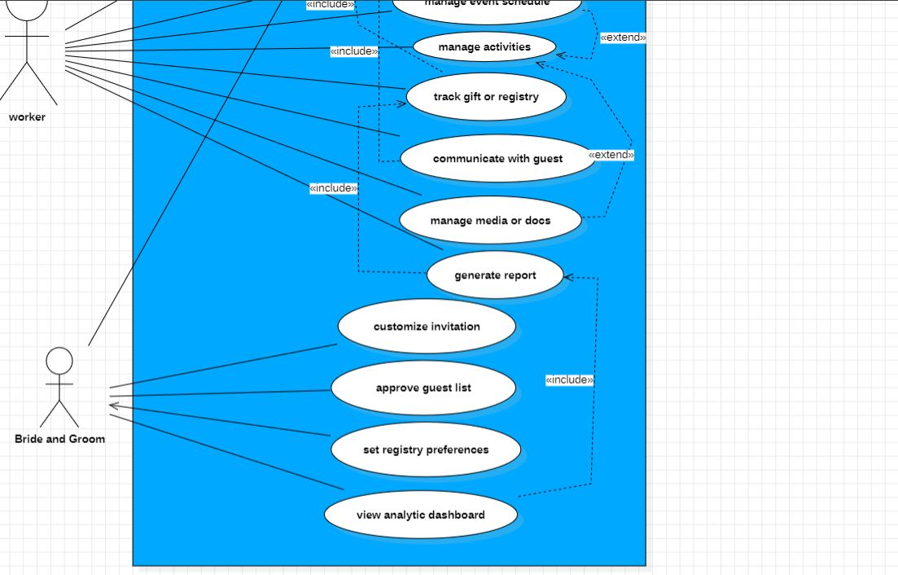
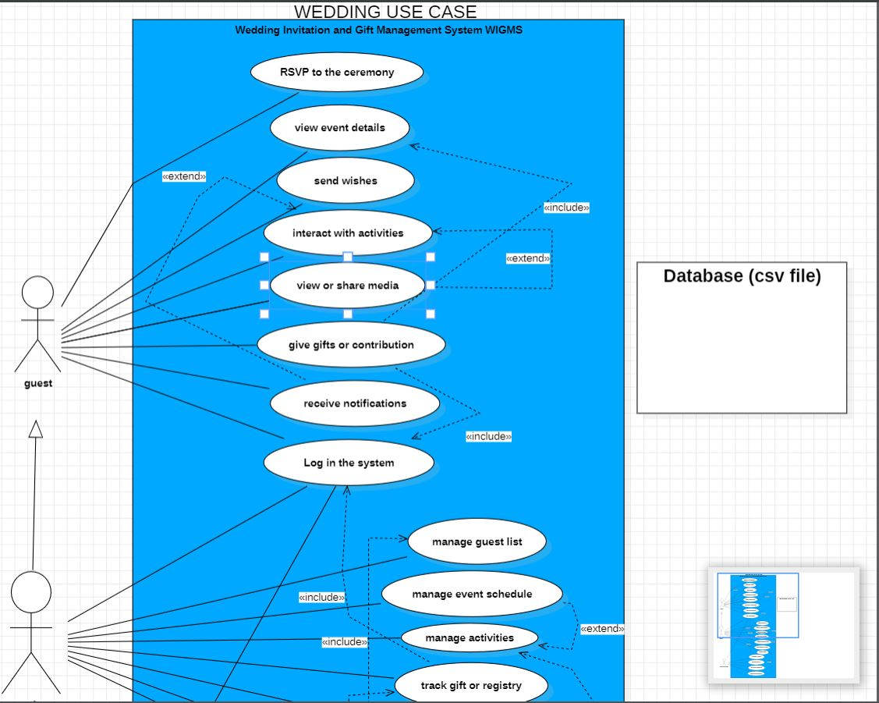
Figure 2: Usecase Diagram — Wedding Management System (StarUML)

12.3 SEQUENCE DIAGRAM

Overview
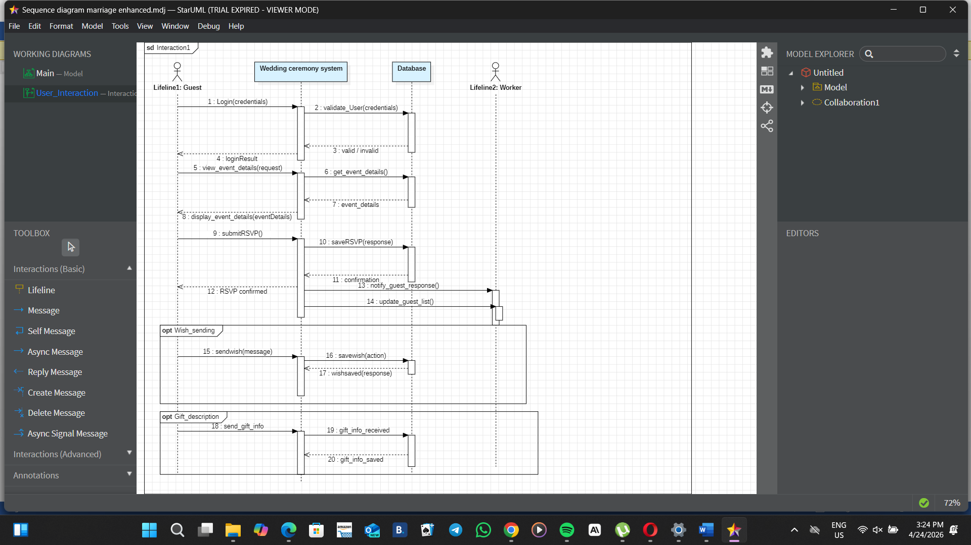
A sequence diagram illustrates how different components of the wedding-planning system interact over time through ordered message exchanges.
Figure 3: Sequence Diagram — Wedding Management System (StarUM
It helps visualize the workflow of actions such as event creation, guest invitations, and RSVP tracking, ensuring processes occur in the correct sequence.

12.4 MNEMONIC TABLE
This table will enable any person familiar with c-programming projects who may or may have not participated in the project to better understand the actions going on represented on both the use case and sequence diagrams already illustrated above.
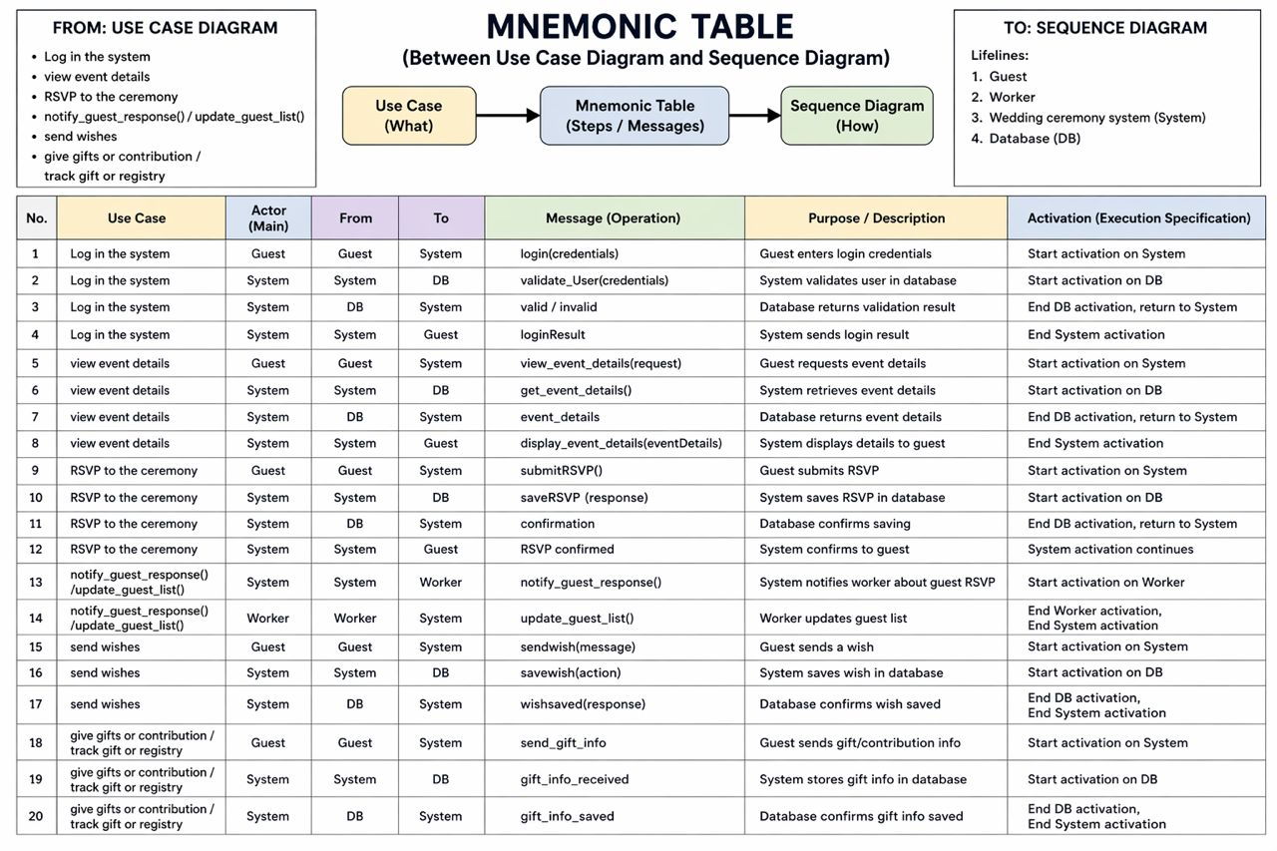
Figure 5: Mnemonic table between the usecase diagram and sequence diagram — Wedding Management System (StarUML)

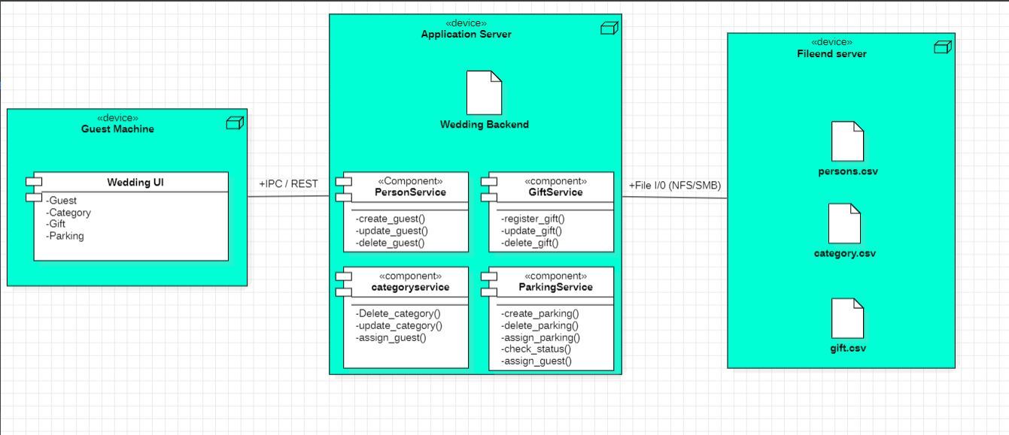
12.5 DEPLOYMENT DIAGRAM
Figure 4: Deployment Diagram — Wedding Management System (StarUML)

GNU Image Manipulation ProgramToolkit (GTK) and Comma-Selected Value (CSV

13.1 GTK
Development of a GTK-based form application written in C for managing wedding guest data. The application collects user input through a graphical interface and stores it in a CSV file.
Program Overview
    - Download and Installation of GTK 4 for windows systems
The program uses GTK4 to create a graphical interface consisting of input fields for Name, Age, Status,
First, you have to download the installer at msys2.org, selecting the first version for Windows.
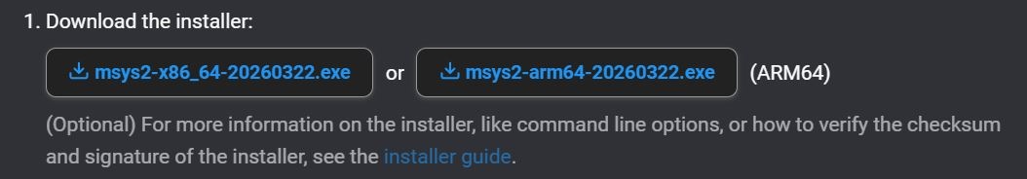
- Following this, at the end of the download process, ensure that you store the installer in a folder you will easily remember e.g wedding management ceremony.
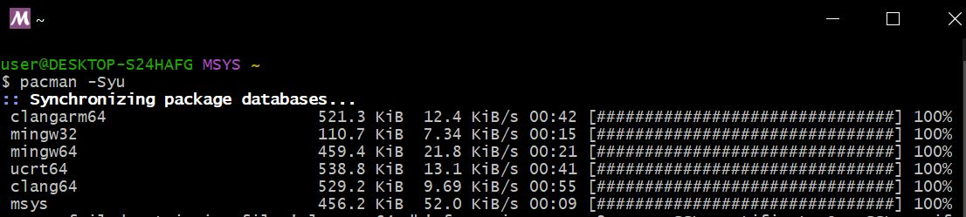
- Again, open the “MSYS2 MSYS” terminal and run the command “pacman -Syu”, and press “Y” until you finalize the installations.
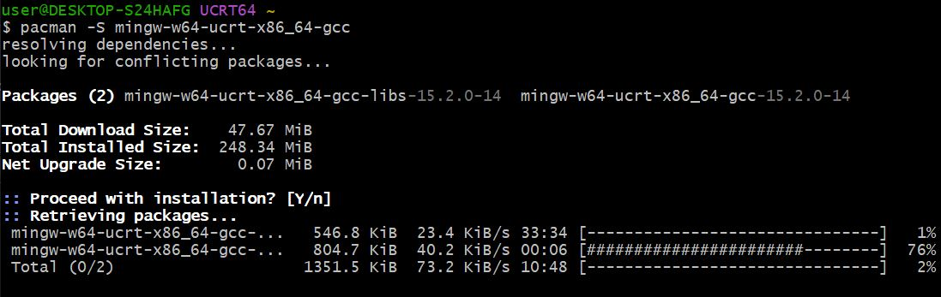
- Still, run the command “$ pacman -S mingw-w64-ucrt-x86_64-gcc” into the “MSYS2 UCR64” terminal, and validate all the options till the end of the various installations.
- To continue, install GTK still in the “MSYS2 MINGW64” terminal by typing the command “pacman -S mingw-w64-x86_64-gtk4”, and then install build tools by typing-in the command “pacman -S mingw-w64-x86_64-pkgconfig mingw-w64-x86_64-make” in the same terminal.

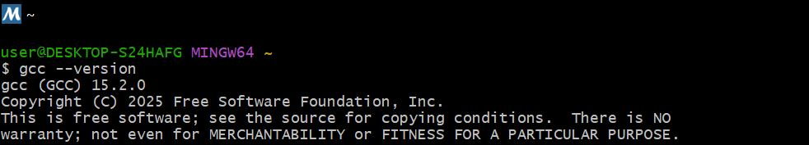
- Next, in order to ensure that the gcc compiler was well installed, run the command “gcc --version” into the “MSYS2 MINGW64” terminal. You should see the version afterwards.

- You have now installed your GTK library, you should procede further with the execution of codes.

NB
- Before running a code, you must make sure that it is stored in the same folder as the one containing your GTK library files.

- If the code ran successfully, a “.exe” fileappears just below you c-code in the folder.
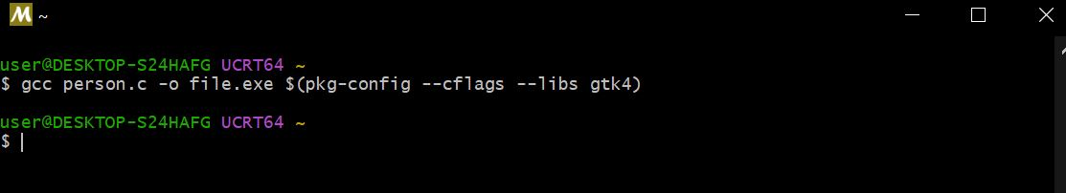
- In order to run the code, you must open the “MSYS UCR64” terminal ad type the command “gcc file.c -o file.exe $(pkg-config –cflags –libs gtk4)”

- Download and installation of GTK for Linux
To install GTK for some particular systems as “Linux”, we follow different steps:
- Step1: Open the terminal
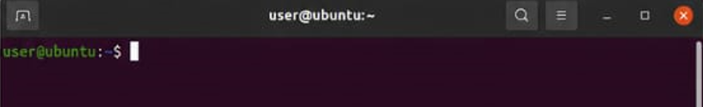
- Step2: Update your system
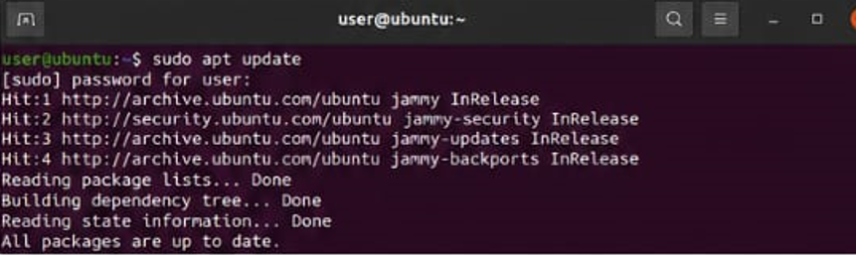
Here, you run the following command “sudo apt update” to update the package list.

- Step3: install GTK
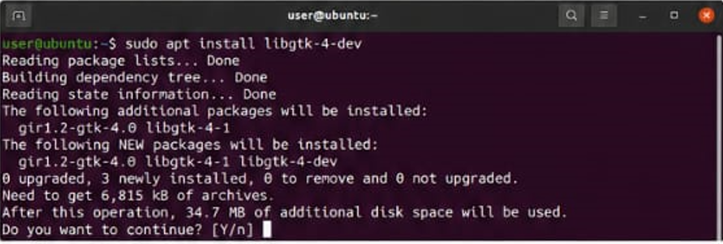
You run the following command “sudo apt install light-4-dev” in order to install the GTK4 development packages
- After entering the command, you need to confirm the installation by “typing Y and press Enter”. Therefore, the packages will be downloaded and installed.
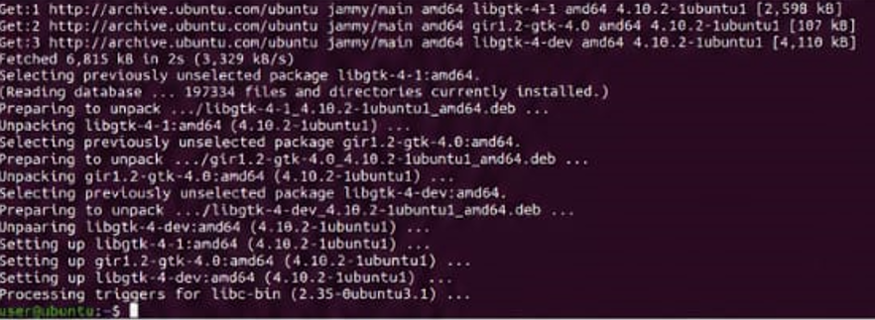
- Step4: Verifying the installation
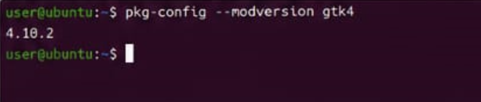
After installing, you need to check the installed GTK4 version. To do it, you enter the command “pkg-config –modversion gtk4”
NB: In order to verify the installed GTK4 ands its functionality, you can decide to create and test a program. To compile the program, you need to enter the following command
“gcc name_of_the_program.c ‘pkg-config –cflags --libs gtk4 -o name_of_the_program”
Then to test, we run: “./name_of_the_program”
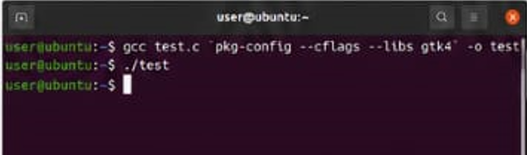
EX:

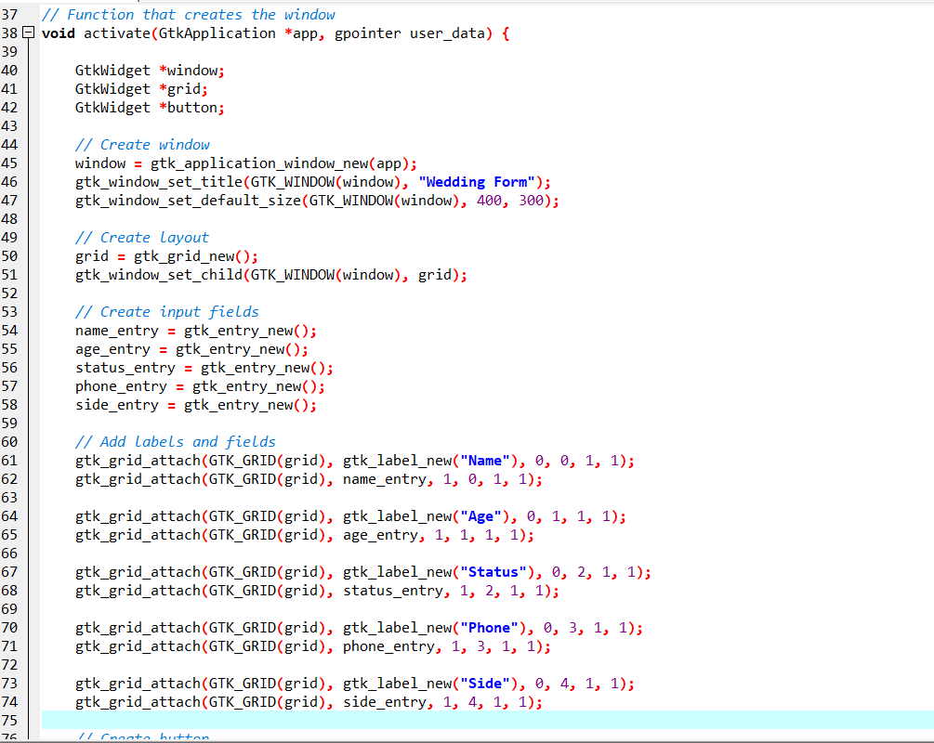
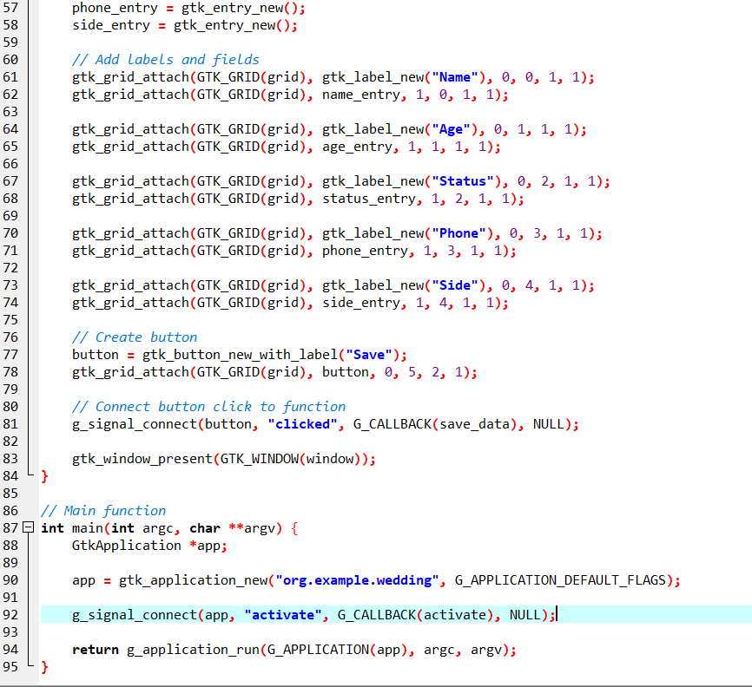
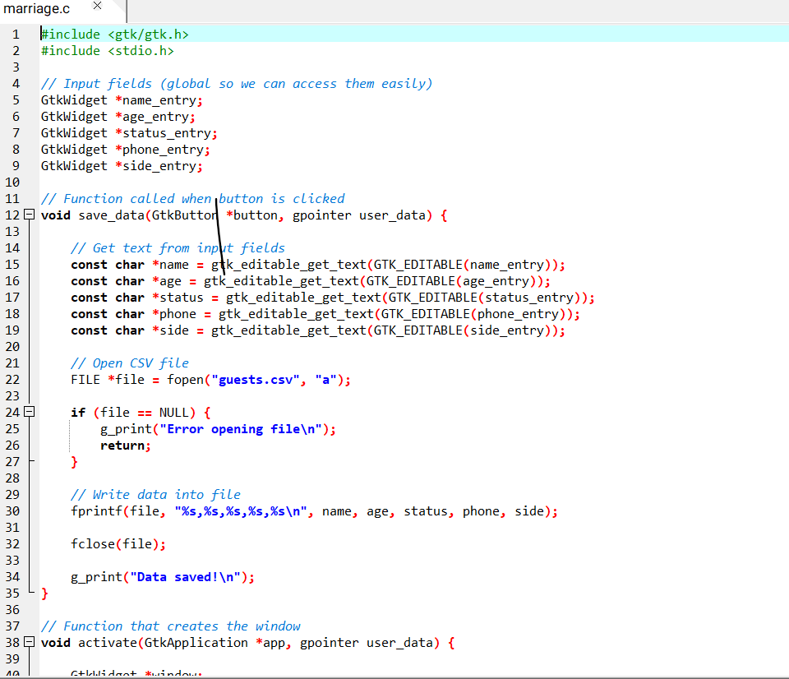
Key Implementation Details

- Global widget pointers were used to allow access to input fields across functions. This simplifies retrieving user input when the Save button is clicked.
- The use of gtk_editable_get_text() allows extraction of user input from each entry field. This is required because GTK widgets do not directly expose their content.
- File handling is implemented using fopen in append mode ("a").
This ensures that new data is added without overwriting existing entries.

14.2 Csv file creation
The csv file was generated immediately after the GTK form worked, and was tested by inputing arbitrary entries
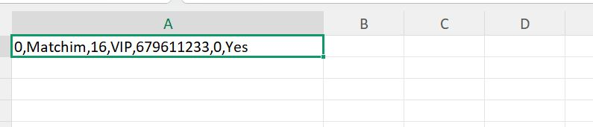
Person csv file

14.3 Problem Encountered and Solution

General Problem
- Difficulty in configuring development tools such as GTK.
- Limited understanding of UML diagrams (sequence, deployment, use case, class).
- Challenges in using StarUML (navigation, relationships, layout).
- Errors in coding such as file handling, compilation, and signal connections.
- Complexity in organizing system interactions and component communication.

14.4 General Solution
- Proper installation and configuration of development tools.
- Studying UML concepts and applying correct diagram rules.
- Practicing and exploring StarUML features for better usage.
- Applying debugging techniques and correct coding practices.
- Breaking the project into smaller tasks using structured planning tools like Gantt charts.

14.5 Conclusion
The Wedding Ceremony Management System demonstrates how C programming can be combined with project planning tools, system design diagrams, and user interface technologies. The use of GTK and CSV enhances usability and data management, making the system efficient and practical for real-world applications.

Person and category management: implementations & tests

Person Management
This module concerns the registration of the guests at a wedding ceremony, alongside all the operations carried out on them (Entry, Update, Delete).
- The previous model in the second report being lacking, the following is an updated version
- The c-program was written and thoroughly debugged using dev c++ software

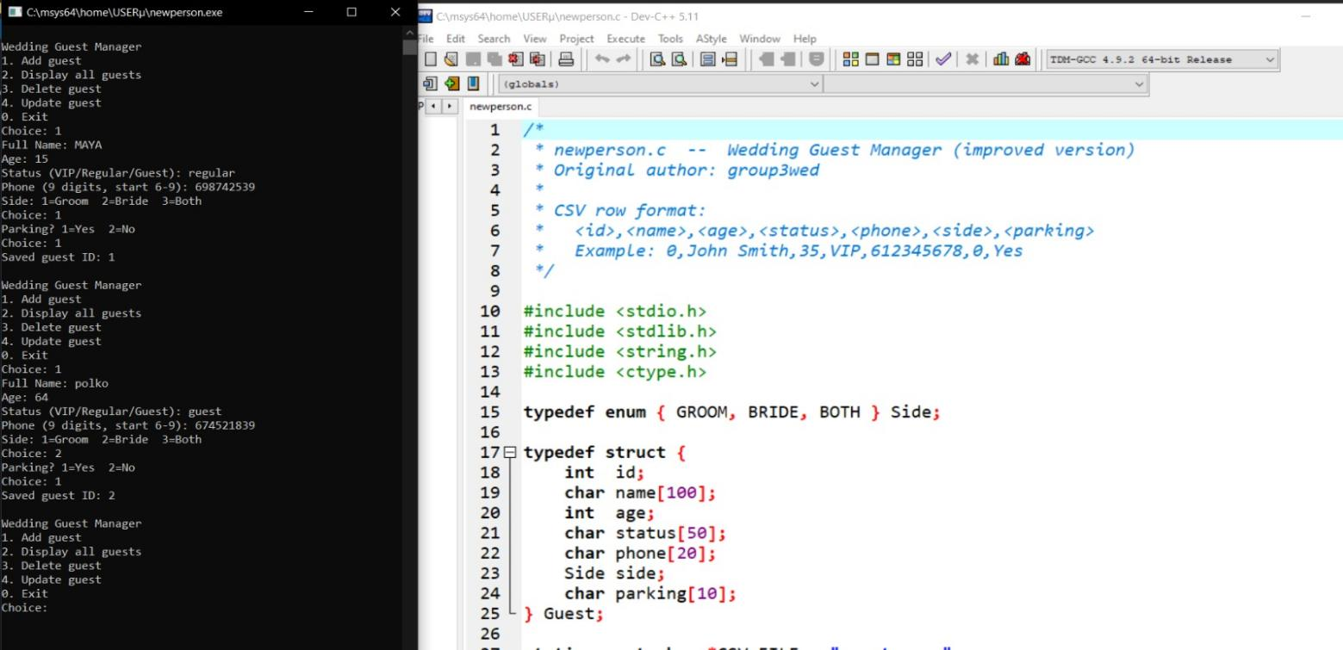
15.1.1 Extract of Person Management C-code

- Once written, the c-program was converted into a GTK form using GTK-specific libraries.

15.1.2 Extract of person management GTK c-code
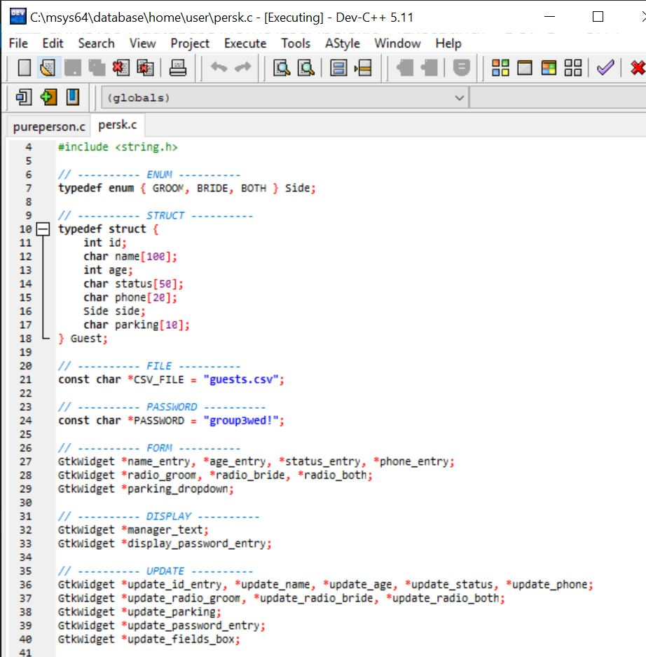

- The csv file was automatically generated below the gtk person management file immediately the gtk compiled successfully.

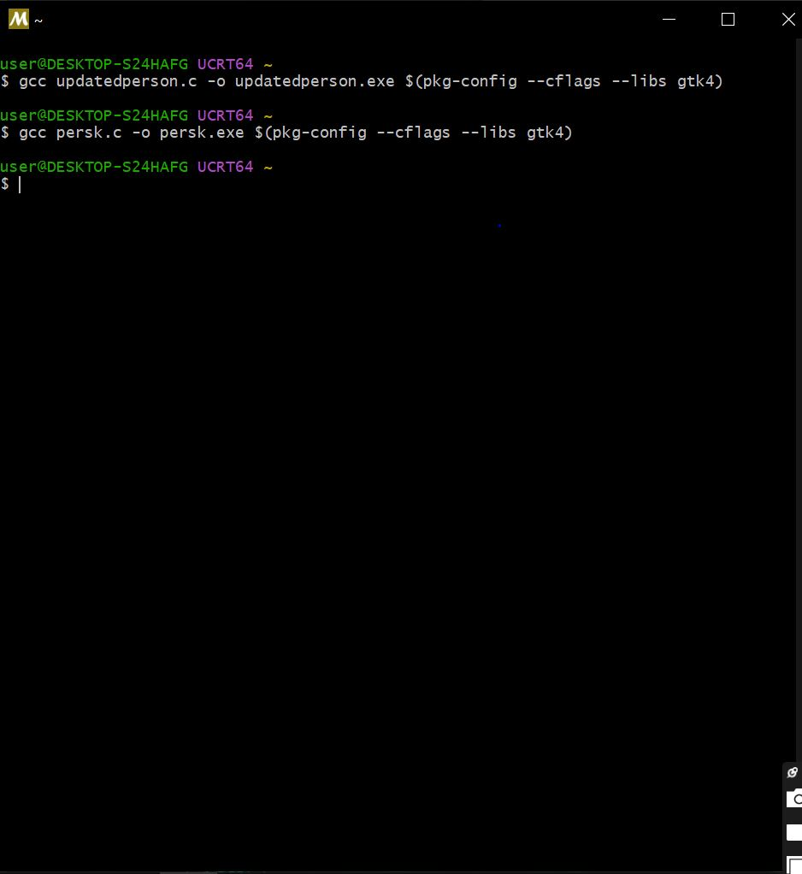
15.1.3 GTK ran successfully

15.1.4 Executable File

- Tests were carried out to verify that the Person management form performs its job correctly

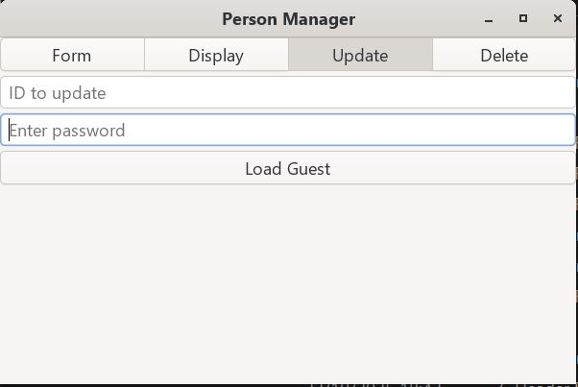
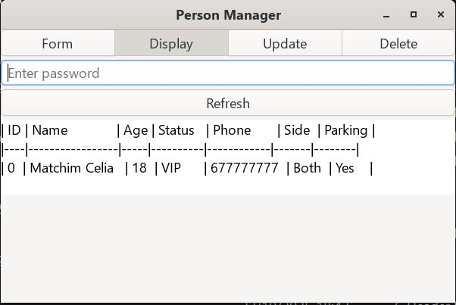
  - Person registration (b) Person update

15.2 Category Management
The category management module was implemented in order to allow for creation of different categories at a wedding ceremony.

-Just like the person management module, alongside all the operations (Display, Update, Delete, Assign Guests)
- For assigning guests, the code was linked to the person management code, through the ID
- The code was thoroughly debugged using dev c++ software

15.2.1 Extract of Category Management C-code
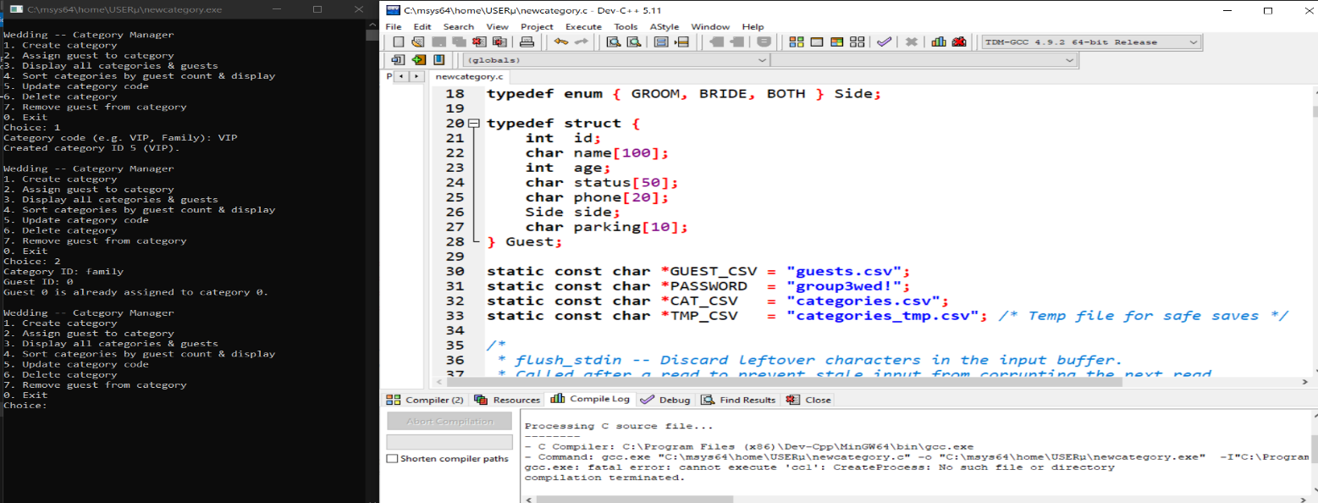
- Once the category management c program was correctly implemented, the GTK form version was created.

15.2.2 Extract of Category Management GTK code
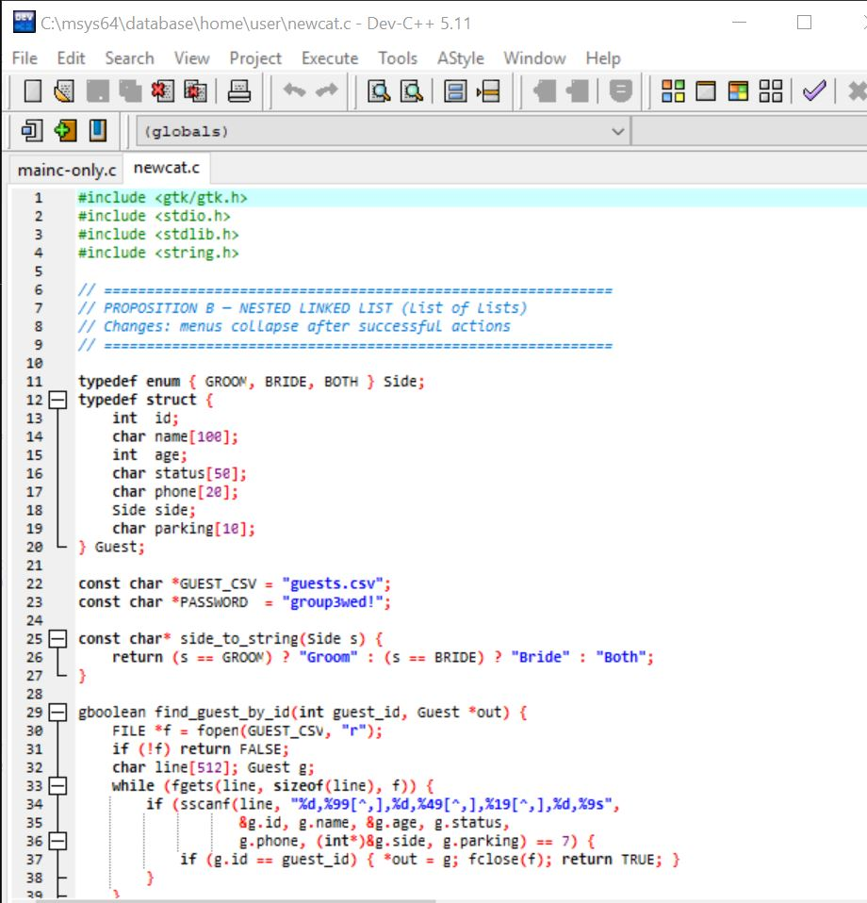

- Haven properly run the code, the csv file was created automatically below the category management.

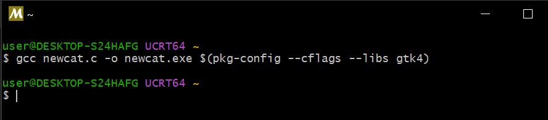
15.2.3 Category ran successfully

15.2.4 Executable file

- Haven properly created the csv file, test were carried out, similarly to those in the person management, to ensure functionability15.2.4 Category Manager Window

15.2.5. Assignment Page
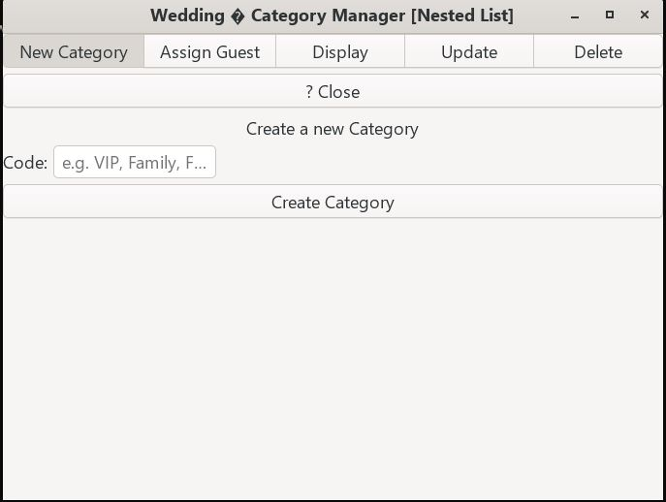

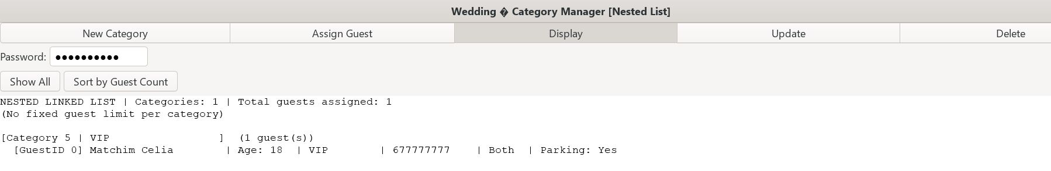

Combination of person and category management onto a single window
Haven made the person and category management fully-functional; it is necessary to combine them in a single window where a user has the possibility of choosing which to fill.
- The c-code, combinedmodules, was written, thoroughly de bugged and converted to a GTK form, and the csv file generated subsequently
- Main code with c only
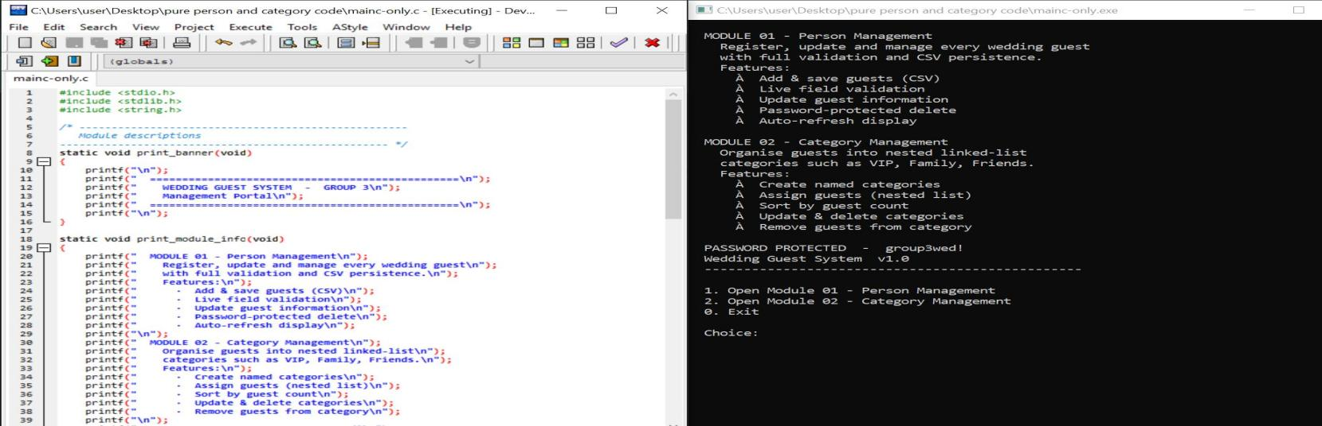
16.1 Extract of combinedmodules.c

16.2 Extract of Main code with Css
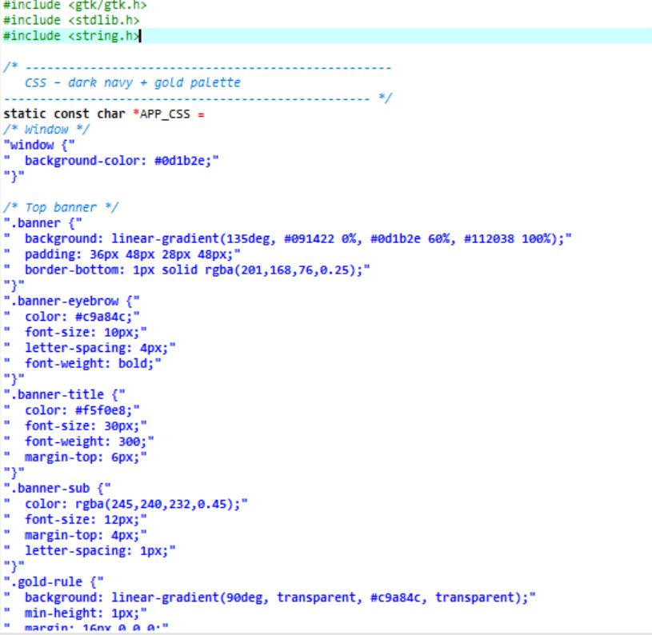
- Css was added to the GTK inorder to beautify the window

16.3 combinemodules ran Successfully
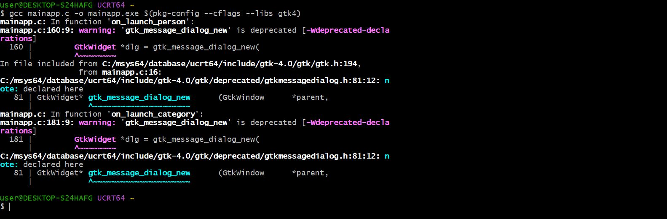

16.4. Executable file

16.5. Combinedmodules Window
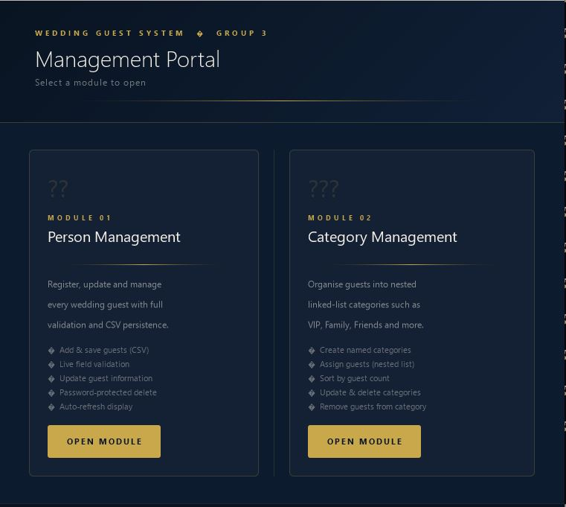

THE GIFT MANAGEMENT
The gift management module was implemented in order manage the possible gifts at a wedding ceremony.
- It helps the couple to know what their guests are planning to give or offer them.
- Furthermore, just like the person and category management module, it carries alongsides all the operations;
- Register
- Display
- Delete
- update gifts from guests

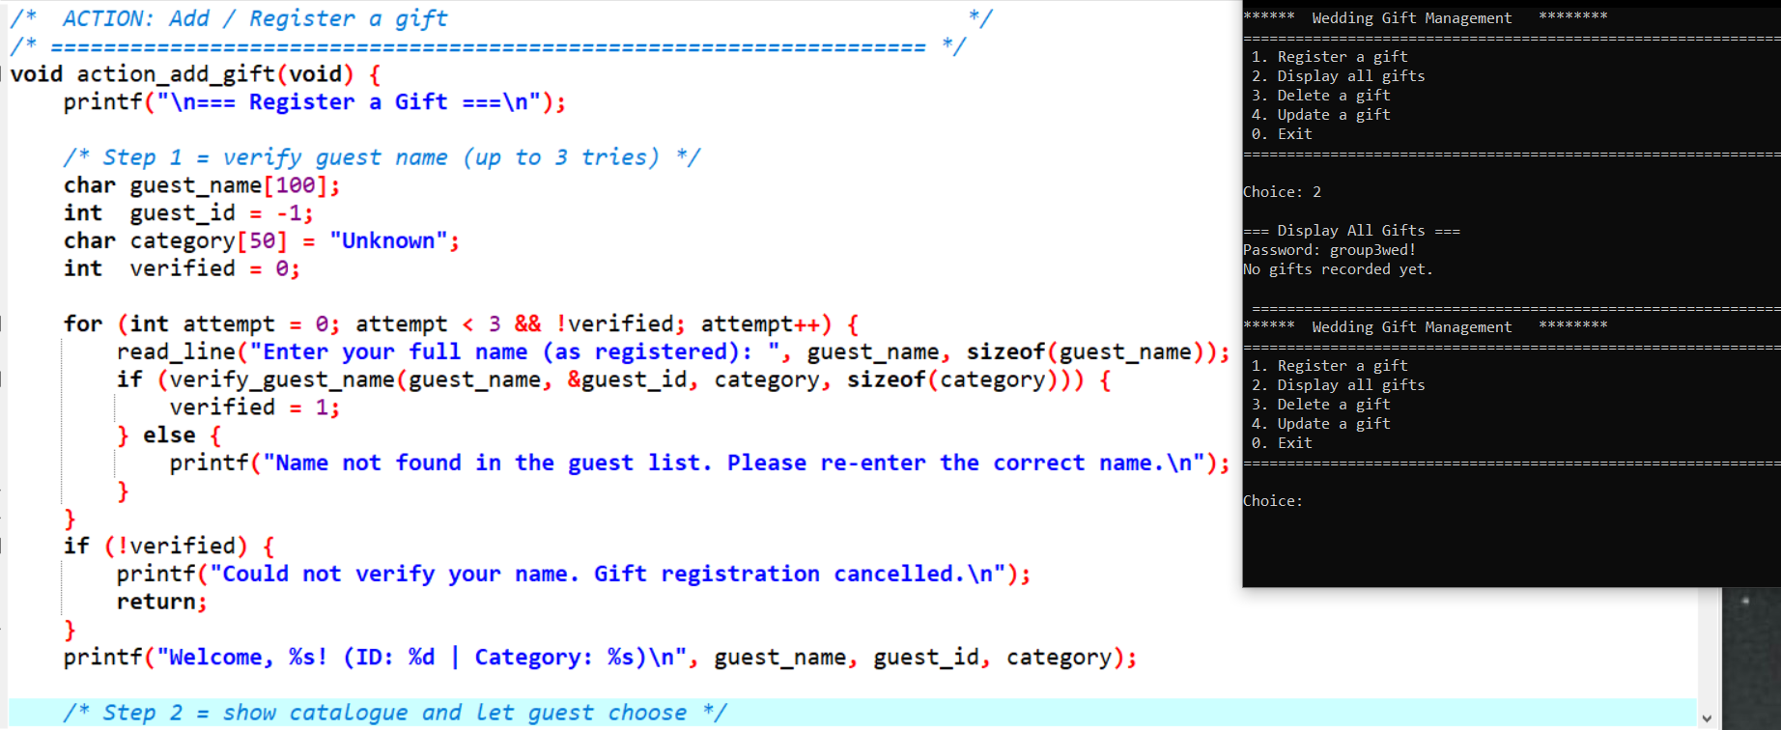
17.1 Extract of Gift Management C-code
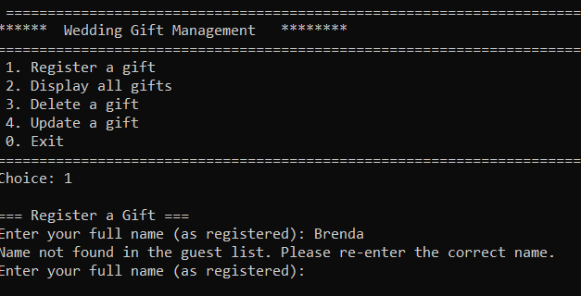

- Once the gift management c program was correctly implemented, the GTK version was created

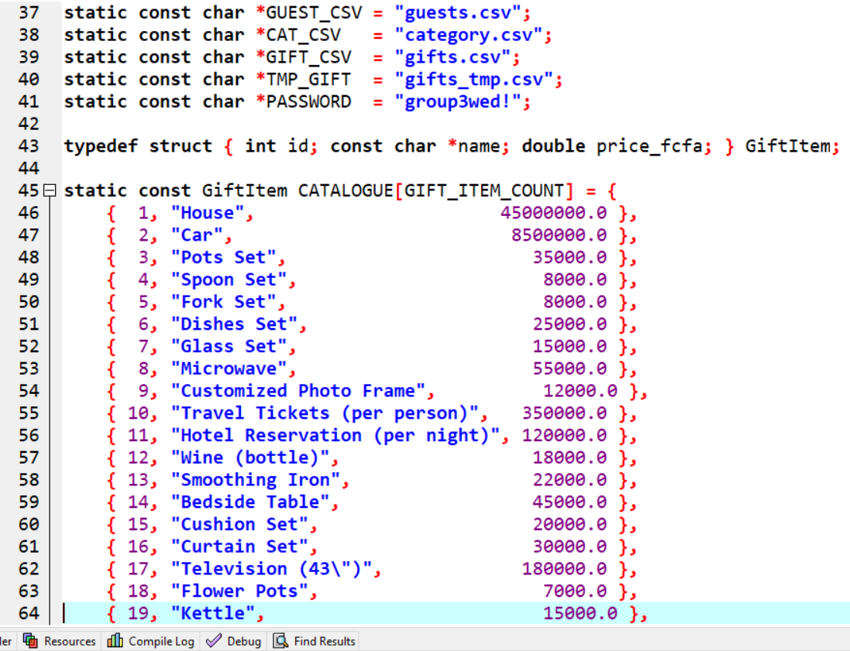
17.2 Extract of Gift Management GTK code

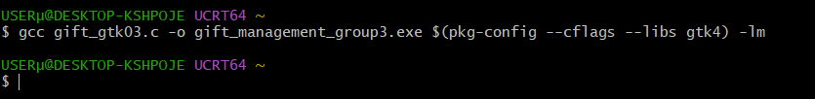
17.3 Gift management ran successfully

Executable file

- Haven properly created the csv file, test were carried out, similarly to those of category and person management so as to insure functionality.
- - We then created the csv file in order to carryout the tests

csv file

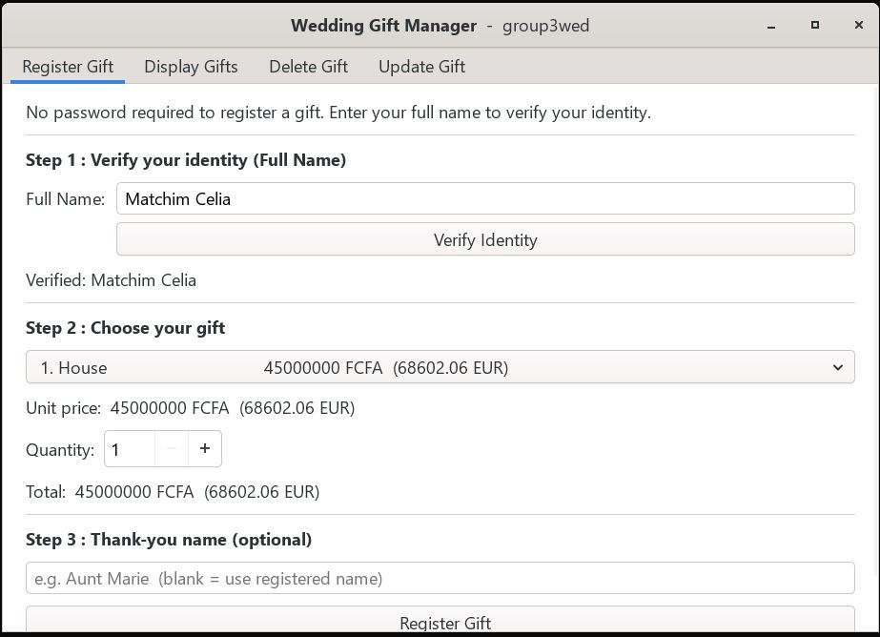
Register a gift
- We implemented registration of a gift by a guest using their name because they do not know the id generated when they registered.

- In order to register a gift, a guest must have first registered in the person module.
- The name Matchim Celia, previously registered in the person.c was successfully identified, showing the success of our code
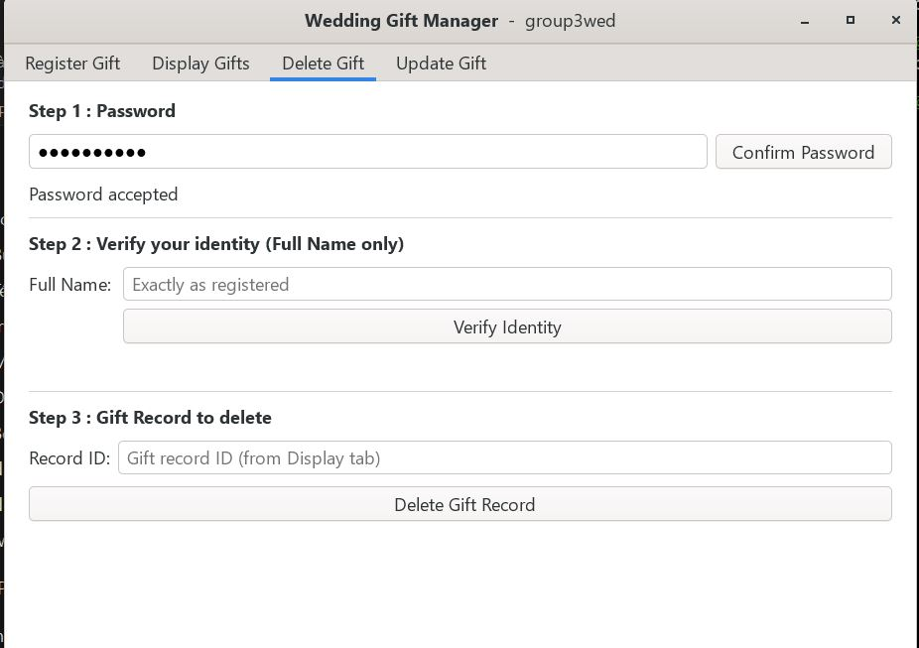
Delete Gift

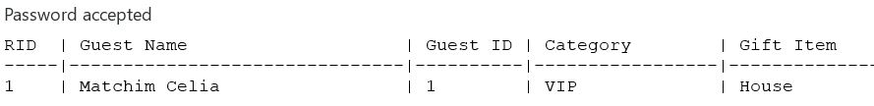
Display Gift
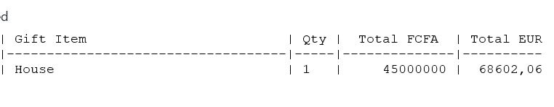
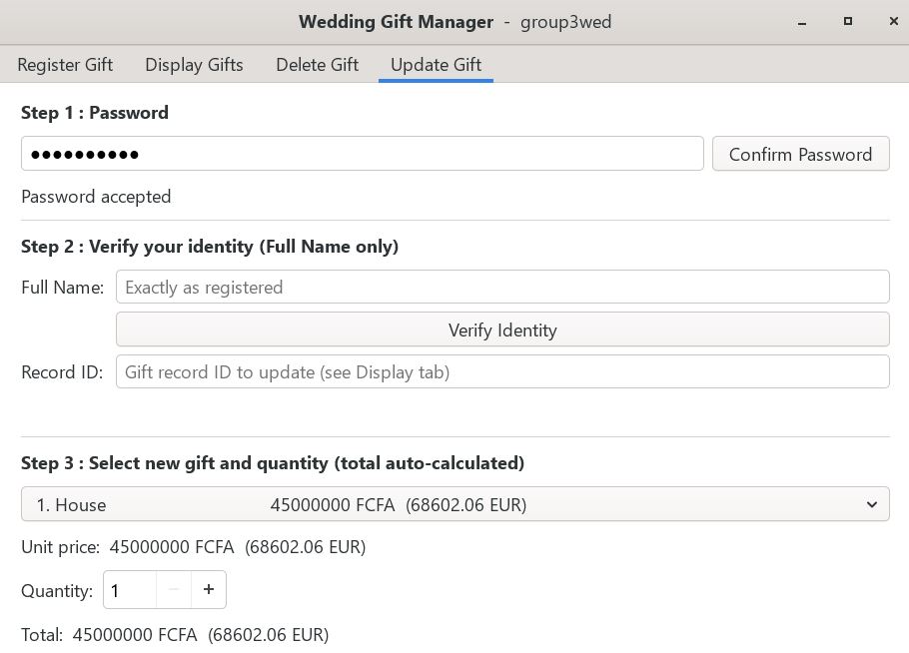
Update Gift
- To display, delete or update a gift, a password must be inserted without which these operations cannot be done.
NB:
- A password was used to prevent guests from accessing fields other than registration. Password: group3wed!
-For being lengthy, full codes could not be integrated in our report. Full codes are available in the GitHub repository at this link: https://github.com/celia-pixel-rgb/Project-Wedding-Ceremony
- All the outputs of the codes are present in the repository too.
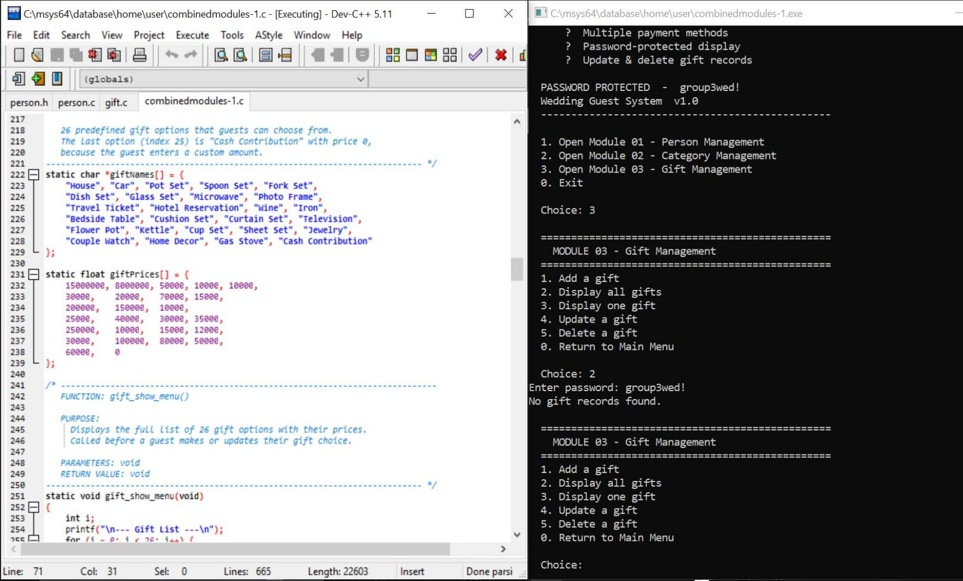
Combinedmodules C Window
- We then added the gift management to our combinedmodules.c

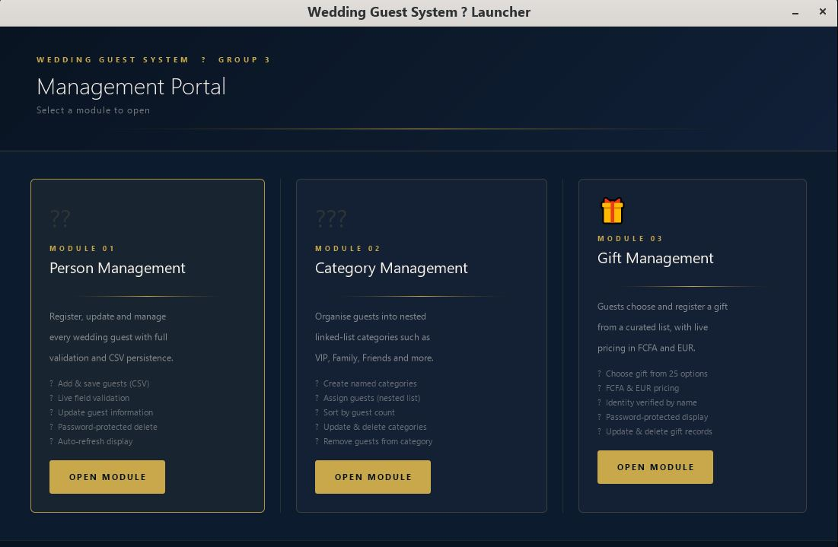
Combinedmodules GTK Window

CREATION OF MAKE FILE
A Makefile is a special text file used with a build automation tool called Make. It tells the tool how to compile, build, and manage a project.
- To better manage our program, we will build a Makefile in order to corelate all the modules.

- Create a file you name Makefile in the same folder as your c programs. You can create it as word, excel, blocnotes etc

- Remove the extension of the file by going to the “Affichage” component and check the box “show ext and safeguard changes, so that your make file has no extension.

- Modify the extention by clicking “Oui” or “Yes.
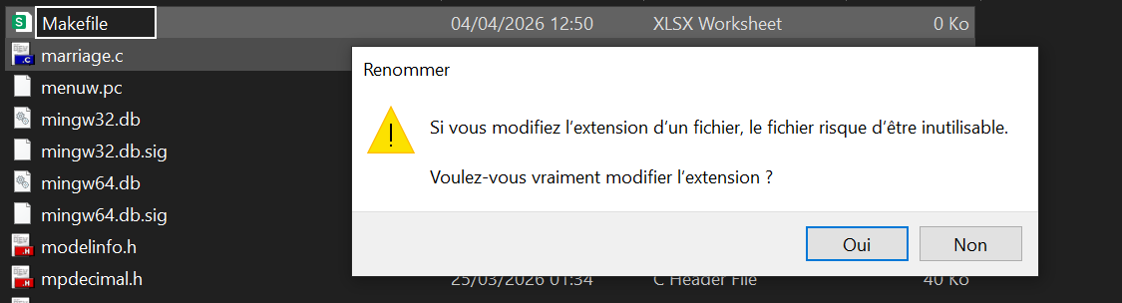

- Your Makefile has been created, you can now procede with writing information into it.
- Open the MSYS2UCRT64 terminal and type in the command to search for the path where your Makefile is found
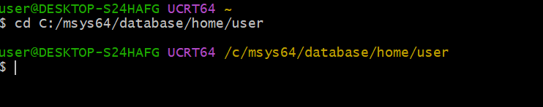

- Type “make” in the terminal, and wait until all the different modules are all compiled.
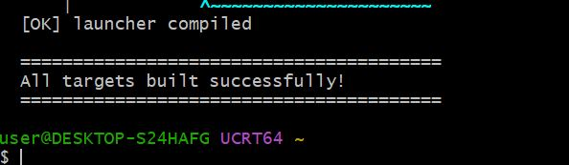

- After your Makefile ran correctly, you can now procede to launch the interface created with all your modules by typing the command “./launcher” in your terminal
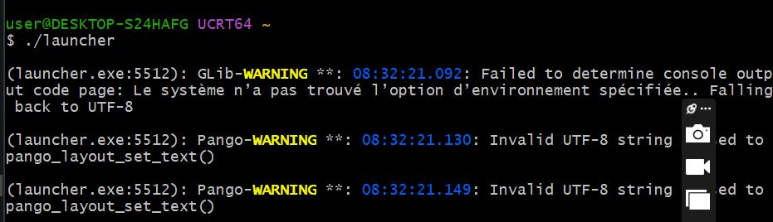

- Once it is done, a cube shaped GTK icon appears in your task bar. Click on it, you will see the interface with all three modules.


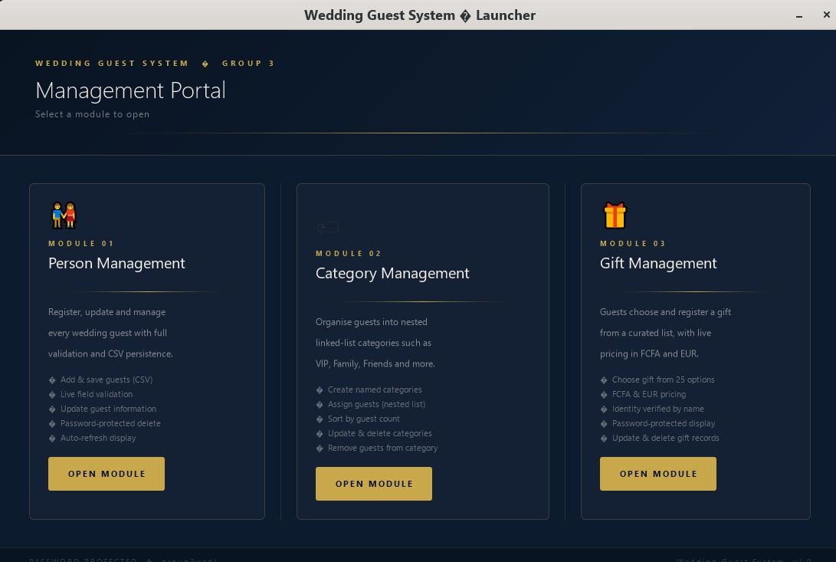

- You use the make clean prompt in order to clear away any actions done in the modules
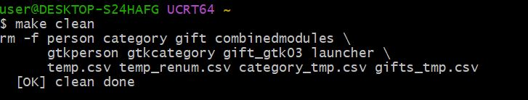

Optimizations Made
- We rendered the id of a person dynamic that is, if someone registers as a guest and has ID 0, and later on with draws, the ID of the persons following will immediately be adjusted; i.e the next will go to 0, and the following to 1…

- Github link: https://github.com/celia-pixel-rgb/Project-Wedding-Ceremony

CONCLUSION
With Modules 1,2 and 3 implemented and optimized, we are ready for the implementation of module 4 and 5, parking management and pririty management.

